

|  |  |
| --- | --- |
|  | **Shutterfly Google Drive Migration**  Office 365 Architecture  Prepared For  Shutterfly  Prepared By  Rabiah Memon, Sr. Solutions Architect  Version 1.0 |

# Revision history

|  |  |  |  |
| --- | --- | --- | --- |
| Date | Author | Version | Description |
| 4/20/2022 | Rabiah Memon | 1.0 | First Draft |
|  |  |  |  |
|  |  |  |  |
|  |  |  |  |

Table of Contents

Revision history 2

About 4

Overview 4

Office 365 Core Components 4

SharePoint Sites 4

Team Sites 4

Communication Sites 4

SharePoint Hubs 5

OneDrive 5

Microsoft Teams 5

Shutterfly Office 365 Migration Architecture 5

Overview 5

Department Hubs 6

About 6

Architecture 6

Hub Navigation 7

Team Sites 7

Usage 7

Site Content 7

Landing Page 8

Communication Sites 8

Usage 8

Site Content 8

Landing Page 9

OneDrive 9

About

This document provides the Office 365 destination architecture for the Google Drive migration. It details the O365 components and structures that will be used for document storage, collaboration, and document publishing.

# Shutterfly Architecture Overview

The goal of the architecture plan is to build a Shutterfly Office 365 architecture that fits the migration plan. Because the migration plan is a “lift-and-shift” type migration (i.e. the folder structure is mostly moving as-is without a major re-structuring of folders), the architecture will focus on these main areas:

* Moving “shared” drives content to private collaborative spaces.
* Enabling users to share collaborative content using O365 best practices.
* Enabling users to share content with large audiences through public spaces.
* Enabling users to store non-collaborative content in personal spaces.

These strategies are somewhat different from Google Drive as content will be stored in new types of spaces (e.g. SharePoint sites). Users will need to adapt to O365 new concepts, structures, and sharing practices.

# Office 365 Core Components

Office 365 has evolved tremendously over the last 5 years with the introduction of the modern SharePoint sites, Microsoft Teams, and OneDrive enhancements.

These modern structures and enhancements provide the core components of the new Shutterfly O365 architecture.

## SharePoint Sites

### Team Sites

SharePoint “Team Sites” will be used to store any content that is shared between group of users who are actively collaborating on the content.

Team Sites are centered around “collaboration” particularly in smaller audiences. These sites are generally private, although content can be shared with outside users.

Team Sites are also backed by a “Microsoft 365 Group” which controls the members to the site. Additionally, the M365 Group enables the team to use other collaborative features such as “Microsoft Teams”, shared mailes, and tasking boards.

### Communication Sites

SharePoint “Communication Sites” will be used as public spaces for departments; allowing uses to publish content to the Communication Site for the purpose of sharing that content with large audiences (e.g. the entire organization).

Communication Sites are not purposed for collaboration, but for sharing information with large audiences.

## SharePoint Hubs

SharePoint Hubs will be implemented to group and unify related SharePoint sites. Sites that are unified within the same hub will share the same global navigation.

SharePoint hubs are perfect for unifying departments and their associated sites.

Shutterfly iHub will become a SharePoint hub in O365 and the content will be migrated from google drives to SharePoint hub’s libraries and lists.

## OneDrive

OneDrive is where personal non-collaborative documents are stored. OneDrive also contains many helpful personalized features such the “Shared with you” area which displays all content that is shared with you.

All of Shutterfly users data will be migrated to OneDrive.

## Microsoft Teams

Microsoft Teams provides additional collaborative functionality for Groups. Each MS Team is associated with a Team Site. MS Teams is related to the migration plan through Team Sites; any Team Site can enable the use of Microsoft Teams.

# Shutterfly Office 365 Migration Architecture

## Overview

Shutterfly’s Office 365 environment will include many SharePoint sites to contain all public and private documents. These sites will be grouped together into multiple SharePoint Hubs; one Hub for each department. Each department hub provides a place for public and private content to be stored and owned by each department.

Additionally, OneDrive will be used by all users for storing personal enterprise files.

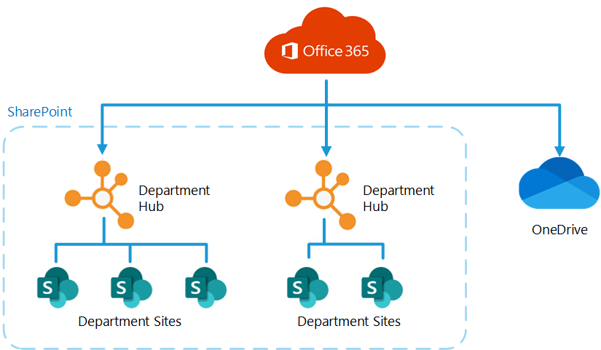

## Department Hubs

### About

Each Shutterfly department (e.g. Communication, Marketing, IT, etc.) will have their own unique SharePoint Hub. Each department hub will include a primary Communication Site for public content and private Team Sites for private/secured content.

Each department hub will also provide navigation for finding sites and other resources within that department.

### Architecture

Within each Shutterfly department hub architecture, there can be multiple communication and team sites:

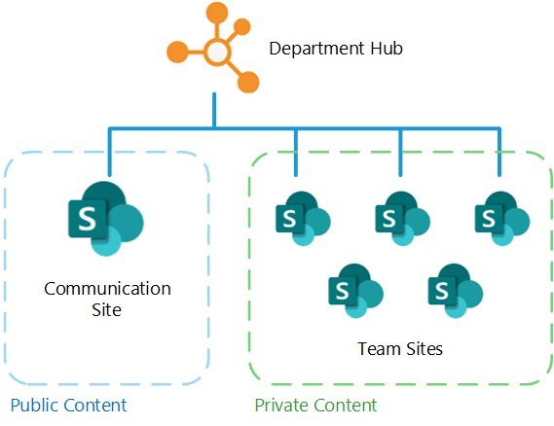

### Hub Navigation

Each department hub will include a global navigation (i.e. Hub Navigation) that will allow users to navigation to the sites within the hub:

In the above diagram there are two top-level items in the Hub Navigation:

* “Department Home” – A link to the department hub home page.
* “Team Sites” – A heading with sub-menu which contains a link to each Team Site within the department.

## Team Sites

### Usage

As mentioned above, each department hub will consist of multiple Team Sites; each Team Site will be used by a single group within the department. Team Sites will be Private for the team members; however, content can be shared within the Team Site to users who are outside the group.

### Site Content

Most document libraries within the Team Site will be private because they inherit permissions from the site (which is Private). However, some libraries or folders can be shared to users outside of the group as needed:

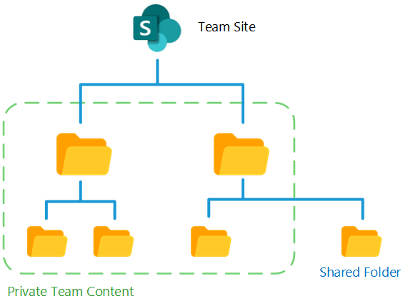

### Landing Page

The landing page for each site will use the standard/default Team Site layout which provides a useful group collaboration experience.

## Communication Sites

### Usage

As mentioned above, each department hub will consist of one Communication Site that will serve as the primary landing page for the department hub.

Additionally, the Communication Site will serve as a place to share information to larger audiences (e.g. the entire organization); it will generally be a public space where department teams and group can publish files and documents which can be accessed by other Shutterfly employees.

### Site Content

Within the contents of the Communication Site, multiple libraries can be configured for different sharing purposes; for example, each team that wishes to share content to a larger audience can create one or more public libraries in the Communication Site:

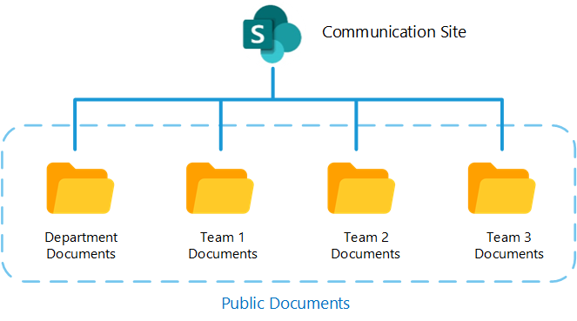

### Landing Page

The landing page for each site will use a custom home page template that includes useful web parts for finding content within the department hub.

This landing page template should be built prior to the beginning of migration.

Recommended web parts to include within the landing page template:

* Quick Links – Links to important department resources/document/folders
* Highlighted Content – Showing the most viewed or trending documents
* My Frequent Sites – Shows the sites the users most frequently visit
* People – Show a list of department contacts or site owners

## OneDrive

OneDrive will be used by all Shutterfly employees to share personal non-shared files; additionally, no external content should be shared with OneDrive. It is preferred that all shared content (internally and externally) be stored in a SharePoint site.

OneDrive has an initial storage limit of 1 Terabyte per users. Larger quantities of files should be kept in a Team Site which has a storage limit of 25 Terabytes per site.